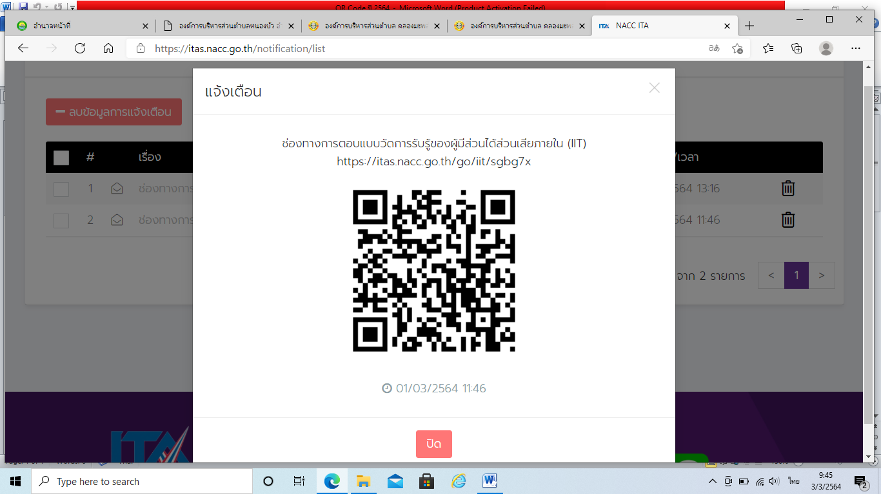

<https://itas.nacc.go.th/go/iit/sgbg7x>